12th Annual
Barlowe 5k Bolt
5K Run and 1 Mile Fun Run/Walk
Proceeds will help in the continuing improvements and maintenance of Barlowe Field
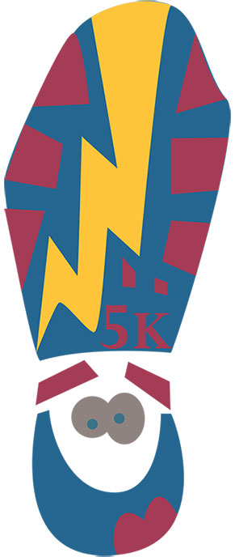
Saturday, March 23, 2024
Starts and finishes at Olde Mill Pool,
490 Chalet Drive, Millersville, MD 21108
Register on www.Active.com
Or by mail
On-site registration and packet pick up start at 6:00 am and the run/walk starts at 7:00 am!

Early bird registration until February 25, 2024
$35 for 5K or 1 Mile Fun Run / Walk

Registration after February 25th is $45 for 5K or 1 Mile Fun Run / Walk
(T-shirts aren’t guaranteed after Early Bird Registration date of February 25th, 2024)
“Like” our Facebook page http://www.facebook.com/BarloweBolt

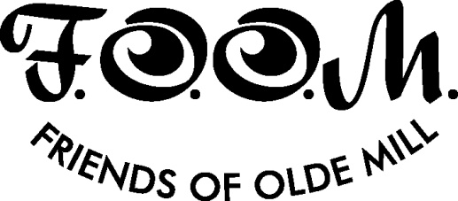
Barlowe 5K Bolt Run/Walk Registration Form (2024)
Name: ______________________________________________________________________
Address: ____________________________________________________________________
E-mail: ____________________________________________ Phone: __________________
Male ____ Female____ DOB_______ Age on Race Day _______
(Circle one to choose your shirt)
Adult T-Shirt Size: S M L XL XXL XXXL
Child’s T-Shirt Size Child’s S Child’s M Child’s L

(Circle one) Early Bird Registration on or before February 25, 2024 (T-shirt guaranteed)
5K $35
1 Mile Fun Run/Walk $35
Registration after February 25, 2024 (T-shirt if available)
5K $45
1 Mile Fun Run/Walk $45

By indicating your acceptance, you understand, agree, warrant and covenant as follows:
Waiver: In consideration of me and/or my minor child being permitted to participate in the Barlowe Bolt, I hereby–for myself, my heirs and personal representatives–assume any and all risks which might be associated with the event. I further waive, release, discharge and covenant not to sue VOMCA (Village of Olde Mill Community Association) or FOOM, Inc. (Friends of Olde Mill), their officers, sponsors, organizers, volunteers or other representatives or their successors and assigns, for any and all injuries or damages of any kind whatsoever suffered by myself and/or my minor child as a result of taking part in the events and any related activities. I also authorize the use by FOOM, Inc. of any photo, film or videotape taken of me or my minor child at the event for any purpose.

Signature: ___________________________________________________________________
Print Name: ______________________________________ Date: ______________________
Mail this form and your check payable to FOOM, Inc. to: FOOM, Inc.; P.O. Box 151; Millersville, MD 21108. Envelope must be postmarked by February 20, 2024 to guarantee a t-shirt. Applications postmarked after this date will receive a t-shirt if any are still available.

